

**Applied Regression Analysis (BUS 41100) -**

**Autumn 2021**

**Final Project**

**Impact of Women and Minority CEOs on Stock Performance**

**Moises Coronado, Doug MacIntosh, Nadia Rangwalla**

December 11, 2021

**Table of Contents**

**Abstract** **3**

**Context** **3**

**Data** **4**

Summary 4

Exhibit 1. Data Dictionary 4

Relationship Between Variables 5

Exhibit 2. Stock Price Over Time (Female vs. Male CEOs) 6

Exhibit 3. Stock Price Over Time (Minority vs. Non-Minority CEOs) 7

**Preliminary Analysis** **7**

Data Limitations 7

Simple Linear Regression 8

Exhibit 4. Results of Simple Linear Regression 8

**Model I: MLR** **8**

MLR Justification 8

Variable Selection 9

Exhibit 5. Variable Selection 9

Exhibit 6. Correlation Matrix 10

Exhibit 7. Results of Multiple Linear Regression 11

Exhibit 8: AIC and BIC Calculations for Model Selection 12

Exhibit 9: Hausman Test Results 12

Regression Results and Interpretation 12

Exhibit 10: Results of Selected Model for Multiple Linear Regression 13

**Model II: Auto-Regressive Model Consideration** **13**

Auto-Regressive Model Justification 13

Model Selection 14

Exhibit 11: ACF for Dataset F - Average Stock Price Increase 14

Exhibit 12: ACF for Dataset M - Average Stock Price Increase 15

Exhibit 13: Regression Results of the AR(1) Model 15

Interpretation 16

**Conclusion** **16**

**Appendix** **17**

Exhibit 14. Distribution of Stock Price (Female CEOs) 17

Exhibit 15. Distribution of Stock Price (Minority CEOs) 17

Exhibit 16. Distribution of Stock Price (Other Companies) 18

Exhibit 18. Complete Results of the Multiple Linear Regression 20

Exhibit 19. Complete Results of the Multiple Linear Regression with Random Effects 21

Exhibit 20. Complete Results of the Multiple Linear Regression with Fixed Effects 22

Exhibit 21. Complete Results of the AR(1) Model - Dataset F 23

Exhibit 22. Complete Results of the AR(1) Model - Dataset M 23

# Abstract

The goal of this paper is to examine how the average stock price growth rate for the largest companies in the United States with a female or minority CEO compares with other companies' financial performance. To achieve this goal, we iteratively build up the model and evaluate the results. First, we use a simple linear regression to understand the general relationship between female-led companies and minority-run companies. Once that is complete, we incorporate other control variables and develop a multiple linear regression model. Finally, we create a time series model that compares the performance of female-run companies to the performance of male-run ones. We find that there is no statistically significant difference in stock price growth over time between female and minority led companies and other major corporations.

# Context

The goal of this project is to understand how diversity amongst executives of major corporations affects the financial performance of the company. In particular, this paper will examine how the presence of a female or minority CEO in a major corporation affects the average stock price growth for the company in comparison to other companies with less diverse leadership in the position.

This is an important topic to explore since Diversity & Inclusion (D&I) in the workplace has never been more at the forefront of conversation than right now. If we can find empirical evidence to support the success of female and minority leadership performance, then there is a case for more inclusion amongst corporate leadership ranks. These results could fuel a corporate board of directors to take more extreme action in increasing the diversity of their leadership, because it directly affects the bottom line of the company, by implementing hiring quotas, or restructuring their current leadership team to have a more diverse perspective.

Similar research has been conducted by other organizations. In 2018, McKinsey released a paper that explores how diversity on the executive board affects profitability. They concluded that in 2017, companies in the top quartile of gender diversity outperformed those in the fourth quartile by 21% in profitability; and companies in the top quartile of ethnic and cultural diversity had a 33% likelihood of outperformance on EBIT margin then those in the fourth quartile.[1] BCG also investigated how diversity in leadership teams affected an organization, and similarly concluded that diverse leadership leads to higher innovation and better financial performance in a company.[2] In this paper, we will take this one step further and delve into the financial effects of gender and ethnic diversity specifically in the CEO position.

# Data

## Summary

This analysis is based on the stock prices of 79 Fortune 500 or S&P 500 companies. We identified 38 of these companies as having a female CEO as of November 2021. We also identified 12 companies with a minority CEO as of November 2021, 6 of these companies have a minority female as a CEO. The other 35 companies in our dataset represent the control group of companies that we pulled at random to use as points of comparison. The dataset includes the monthly stock prices for each of these companies. For minority and female led companies, the stock prices begin on the month the CEO was named. The control companies have stock prices for the same corresponding time period. The data also includes education information on the CEO. Lastly, the dataset includes information on stock price indices and economic growth factors. A detailed outline of fields available in the dataset is in Table 1 below.

### Exhibit 1. Data Dictionary

| **Variable Name** | **Description** |
| --- | --- |
| stock | Name of the stock as traded (ex. AMD, GM, DUK) |
| date | The date of the stock price - stock prices were pulled for the first day of each month |
| period | An index for date |
| price | The closing stock price on the associated date |
| pct_change | Percent change in stock price from one month to the next, calculated as (Pricet - Pricet-1) / Pricet-1 |
| avg_change_woman | Average percent change in stock price from month-to-month for companies with a female CEO |
|  |  |
| avg_change_men | Average percent change in stock price from month-to-month for companies with a male CEO |
| avg_change_minority | Average percent change in stock price from month-to-month for companies with a minority CEO |
| avg_change_non_minority | Average percent change in stock price from month-to-month for companies with a non-minority CEO |
| woman | A flag for whether the CEO was a female. |
| minority | A flag for whether the CEO was a minority. Minority flags were based on self-identification. Those that identified with White (Non-Hispanic) were omitted from this category since they comprise the racial majority in the United States. |
| educationUndergrad | A flag for whether the CEO obtained an undergraduate degree |
| educationGraduate | A flag for whether the CEO obtained a graduate degree (incl. JD, MBA, Masters, and PhD) |
| NASDAQ | NASDAQ Composite[3] |
| SP500 | S&P 500[4] |
| DOWJONES | Dow Jones Industrial Average[5] |
| CPI_Price | Consumer Price Index[6] |
| Unemployment_rate_percent | Seasonally Adjusted, Civilian Unemployment Rate[7] |
| FEDFUNDS | Average Monthly Federal Funds Effective Rate[8] |

## Relationship Between Variables

We started with visualizing the data. In Figure 1 below, we plotted the stock price over time, differentiating companies with female and male CEOs. Based on the chart, we can see that stock prices increase over time. There appears to be constant variation between prices, although it appears that companies with female CEOs tend to have lower stock prices than those with male CEOs.

### Exhibit 2*.* Stock Price Over Time (Female vs. Male CEOs)

We created a similar chart (Figure 2), that plots stock price over time, differentiating between minority and non-minority CEOs. In earlier years (pre-2017), it appears that non-minority led companies had higher stock prices, but in recent years the stock prices for companies with minority CEOs appear to be higher.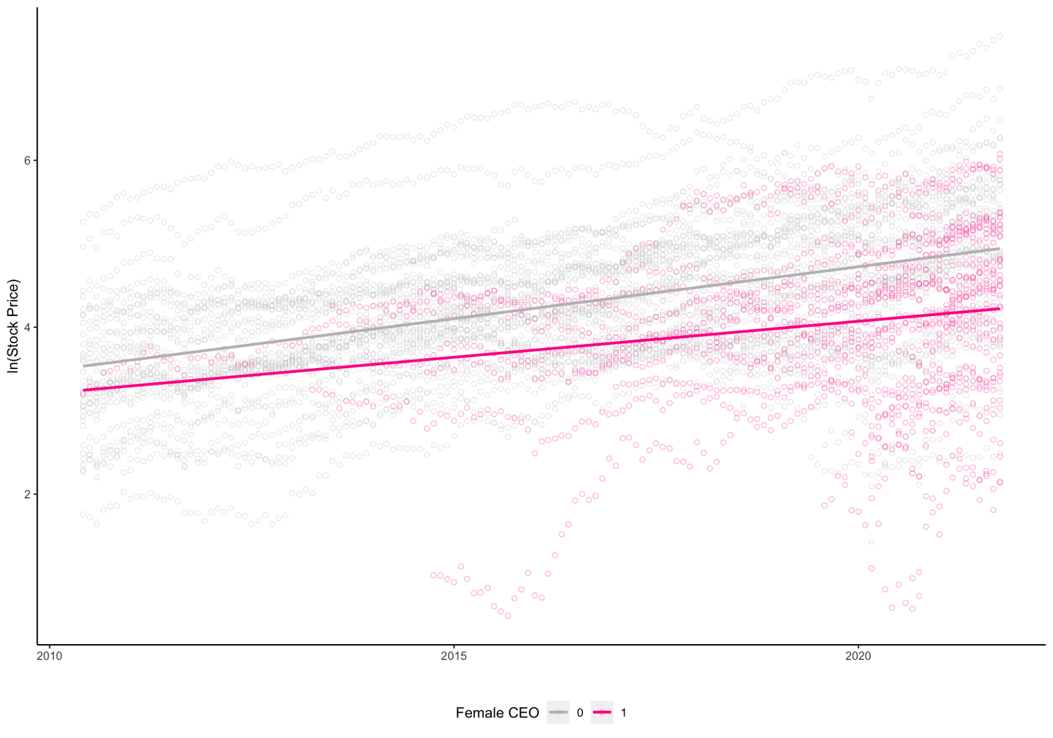

### Exhibit 3. Stock Price Over Time (Minority vs. Non-Minority CEOs)

# 

We also looked at the distribution of stock price for each company in our dataset by plotting boxplots. These boxplots can be seen in the Appendix. Based on these plots, we can see the distribution of stock price varies across companies, with some companies have a small range of prices while other companies having a larger range.

# Preliminary Analysis

## Data Limitations

As we compiled the data, we found that the number of female and minority led companies was small compared to the universe of publicly traded companies. We have seen an increase in the number of female and minority CEOs over time, perhaps because of the growing recognition of the importance of D&I in the workplace. Before the 2000s, there was minimal amounts of data for publicly traded companies with diverse CEOs at the helm. Understanding that as a possible limitation, we chose to use stock price information from companies that currently employ a female CEO rather than pull data from previous tenures, as we believed this would illustrate the current climate best. Therefore, the data is concentrated from May 2015 through October 2021, which we felt was an adequate amount of data points to determine the effect of a CEO’s tenure.

Additionally, out of our 79 companies selected, only 12 companies had a minority CEO (6 male and 6 female). We chose to track the company’s growth rate after the CEO took charge rather than compare the before and after effects within the company. We did this because our goal was to determine the effect of the CEO on growth rate in comparison to other companies rather than itself.

## Simple Linear Regression

We began by using a simple linear regression log model to understand the percent change relationship between our variables. In the initial analysis, we wanted to understand the relationship between the female-run versus non-female-run companies’ prices. Figure 3, below, summarizes the results of the regression. For the companies that did have women as CEOs, we had an average drop of -27.9% in company stock price. Now, this regression does not take into account the overall market trends over time or any of the other variables we noted previously. When we run the regression for minority CEOs, we see the opposite. For the companies in our data that did have minorities as CEOs, we had an average gain of 20.5% in stock price. As we move forward in our model building, we will analyze our methods and incorporate the other variables to improve our model. The full output of these regressions can be found in the Appendix.

### Exhibit 4. Results of Simple Linear Regression

|  | (1) | (2) |
| --- | --- | --- |
|  | ln(Stock Price) | ln(Stock Price) |
| Intercept | 4.265*** | 4.175*** |
|  | (0.0129) | (0.0122) |
| Woman = 1 | -0.279*** |  |
|  | (0.027) |  |
| Minority = 1 |  | 0.205*** |
|  |  | (0.034) |

# Model I: MLR

## MLR Justification

We believe that an MLR is a starting point to begin to understand the relationship between stock performance of minority-run businesses relative to the performance of multiple stock indices.

We will create our MLR by taking the following approach:

1. Selecting model variables
2. Interpreting results
3. Examining alternative models

## Variable Selection

We took a 5 step approach in selecting variables for our MLR:

1. Used intuition and understanding of current market elements contributing to stock price to determine base variables selected
2. Conducted multicollinearity analysis to eliminate independent variables
3. Analyzed base model results to determine the statistical significance of variable coefficients
4. Considered interaction variables and analyzed coefficient significance
5. Utilized formal model selection tools to verify variable selection

Our first step in the variable selection process is to use our intuition to determine potential variables that might affect the performance of stock prices. The below table outlines the variables included in our initial model:

### Exhibit 5. Variable Selection

| **Variable Name** | **Inclusion in Initial Model** | **Correlation with Stock Price** |
| --- | --- | --- |
| stock | No | - |
| date | No | - |
| price | Yes - Dependent Variable | - |
| woman | Yes | Positive |
| minority | Yes | Negative |
| educationUndergrad | No | - |
| educationGraduate | Yes | Positive |
| NASDAQ | Yes | Positive |
| SP500 | No | - |
| DOWJONES | No | - |
| CPI_Price | Yes | Positive |
| Unemployment_rate_percent | Yes | Negative |
| FEDFUNDS | Yes | Positive |

We chose to exclude the flag for undergraduate education as almost all CEOs in our data had obtained a Bachelors. We only kept one price index in our model (NASDAQ) as we know that the prices amongst indices are too closely correlated.

We then choose to explore multicollinearity effects and created a multicollinearity matrix to get a better understanding of the correlation between each of the independent variables:

### Exhibit 6. Correlation Matrix

From this matrix, we can see that CPI price correlates with our index prices. This means that if we include both our index and CPI price into our model, we will not be able to differentiate their effects. We believe that the index prices are a more relevant barometer for our individual stock price changes and therefore choose to exclude the CPI variable from our model.

We ran the model (Model 1): *ln(Stock Price) = β0 + β1× Woman + β2 × Minority + β3 × Graduate Education + β4 × NASDAQ + β5 × Unemployment Rate + β6 × FEDFUNDS + ε.* At an alpha level of 0.05, all of the coefficients are significant. Regression coefficients can be found in Figure 5 below, full results are available in the Appendix.

### 

We then considered the addition of two interaction variables:

1. Minorities and Graduate Degrees
2. Women and Graduate Degrees

Through our research, we noticed that most minority CEOs had at least one graduate degree (JD, MBA, or PhD) and had been long-tenured within their companies (greater than 5 years). As a result, we were interested in understanding the interaction effect between minorities and those with a graduate degree. We ran the model (Model 2): *ln(Stock Price) = β0 + β1× Woman + β2 × Minority + β3 × Graduate Education + β4 × NASDAQ + β5 × Unemployment Rate + β6 × FEDFUNDS + β7  × Minority × Graduate Education + ε.* Through the partial-F test we found that the interaction between minority and graduate education was not statistically significant at an alpha level of 0.05. Results of this model can be found in Figure 5 below and more detail results can be found in the Appendix.

We then modeled the following model (Model 3): *ln(Stock Price) = β0 + β1× Woman + β2 × Minority + β3 × Graduate Education + β4 × NASDAQ + β5 × Unemployment Rate + β6 × FEDFUNDS + β7  × Woman × Graduate Education + ε.* We found that the interaction effect between women and graduate education was statistically significant at an alpha level of 0.05. Result below in Figure 5, and full output in the Appendix.

### Exhibit 7. Results of Multiple Linear Regression

|  | (1) | (2) | (3) |
| --- | --- | --- | --- |
|  | *ln(Stock Price)* | *ln(Stock Price)* | *ln(Stock Price)* |
| Intercept | 3.712*** | 3.712*** | 3.618*** |
|  | (0.055) | (0.055) | (0.057) |
| Woman = 1 | -0.523*** | -0.523*** | -0.3118*** |
|  | (0.0269) | (0.0273) | (0.0421) |
| Minority = 1 | 0.107*** | 0.104 | 0.104*** |
|  | (0.0314) | (0.0856) | (0.3475) |
| Graduate Education | 0.2526*** | 0.2526*** | 0.3475*** |
|  | (0.024) | (0.025) | (0.02796) |
| Nasdaq Composite | 0.00009*** | 0.00009*** | 0.00009*** |
|  | (0.000003) | (0.000003) | (0.000003) |
| Unemployment Rate | -0.0391*** | -0.0391*** | -0.03803*** |
|  | (0.0062) | (0.0062) | (0.0062) |
| Federal Funds | 0.106*** | 0.106*** | 0.106*** |
|  | (0.0162) | (0.0162) | (0.0164) |
| Minority = 1 * Graduate Education |  | 0.0036 |  |
|  |  | (0.0925) |  |
| Woman = 1 * Graduate Education |  |  | 0.345*** |
|  |  |  | (0.05286) |

Finally, we use formal model selection tools to further assess variable inclusion in our model. We compare our initial MLR model to our new model that includes our interaction variable and arrive at the following results:

### Exhibit 8: AIC and BIC Calculations for Model Selection

|  | MLR | MLR + Interaction Term |
| --- | --- | --- |
| AIC | -2148 | -2189 |
| BIC | -2101 | -2134 |

We can see that our new model with the interaction has a lower AIC and BIC and is likely the better model to understand the relationship between female CEOs and stock performance.

Based on these results the variables we select are the following: *Woman, Minority, Graduate Education, Nasdaq Composite, Unemployment Rate, Federal Funds, and Woman * Graduate Education.* As we are interested in inference and not predictability, we forgo stepwise regression and LASSO selection methods that are better suited for predictability than inferential analysis.

Up to this point we had not considered the time and firm effects. We built both a random and fixed effects model to account for these. The full results of these can be found in the Appendix. We then ran a Hausman Test and concluded that the random effects model was best to use.

### Exhibit 9: Hausman Test Results

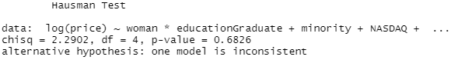

## Regression Results and Interpretation

We settled on an MLR model expressed as follows: *plm.random <- plm(log(price) ~ woman*educationGraduate + minority + NASDAQ + Unemployment_rate_percent + FEDFUNDS, data = clean4, index=c("ï..stock", "period"), model = "random").* The output of the regression is below (more detailed version available in the Appendix.

### Exhibit 10: Results of Selected Model for Multiple Linear Regression

|  |  |
| --- | --- |
|  | *ln(Stock Price)* |
| Intercept | 3.5688*** |
|  | (0.02597) |
| Woman = 1 | -0.34131 |
|  | (0.34276) |
| Minority = 1 | 0.031081 |
|  | (0.0390) |
| Graduate Education | 0.2808 |
|  | (0.0293) |
| Nasdaq Composite | 0.0001*** |
|  | (0.000002) |
| Unemployment Rate | -0.0396*** |
|  | (0.0028) |
| Federal Funds | 0.0856*** |
|  | (0.00736) |
| Woman = 1 * Graduate Education | -0.47725 |
|  | (0.3996) |

Based on these results, we see that once we include random effects for time and stock both the woman, and minority flags, as well as the interaction between woman and graduate education are all not significant at a 0.05 alpha level. Based on these results we conclude that there is no significant difference in the performance of stocks over time for female or minority CEOs in comparison to our random sample of non-female, non-minority led companies.

# Model II: Auto-Regressive Model Consideration

## Auto-Regressive Model Justification

Our next step is to understand if women-led companies outperform stock indices. We believe that by comparing the growth trends as a function of past performance for women and non-women led companies, we should be able to identify if there is difference in performance across groups.

We will create our model through a five step approach:

1. Create average stock price change month-to-month for female and male led companies in the data
2. Examine correlation between time dependent variables
3. Run an AR(1) model for each dataset
4. Examine findings for each dataset and update variables based on results
5. Select final models and compare the betas between datasets

## 

## Model Selection

We begin by finding the correlation between the previous stock price change and the future stock price change for both of our data sets (Dataset F = dataset with companies with female CEOs, Dataset M = dataset with companies with male CEOs):

* Dataset F: -0.07
* Dataset M: -0.14

The lack of correlation between the variables suggests that an auto-regressive model will not be an accurate predictor of the future. This is further confirmed by examining the ACF plots below (Exhibit 11 & Exhibit 12).

### 

### Exhibit 11: ACF for Dataset F - Average Stock Price Increase

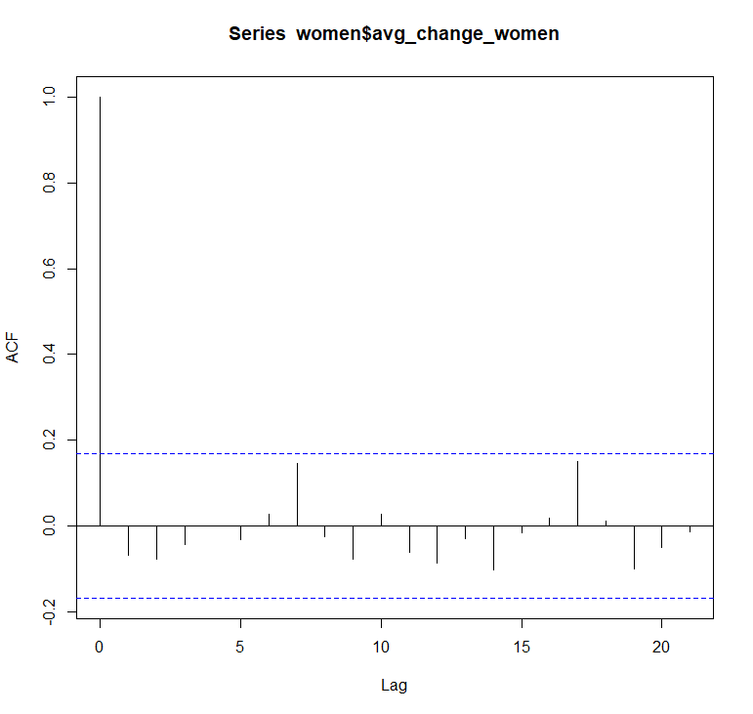

### Exhibit 12: ACF for Dataset M - Average Stock Price Increase

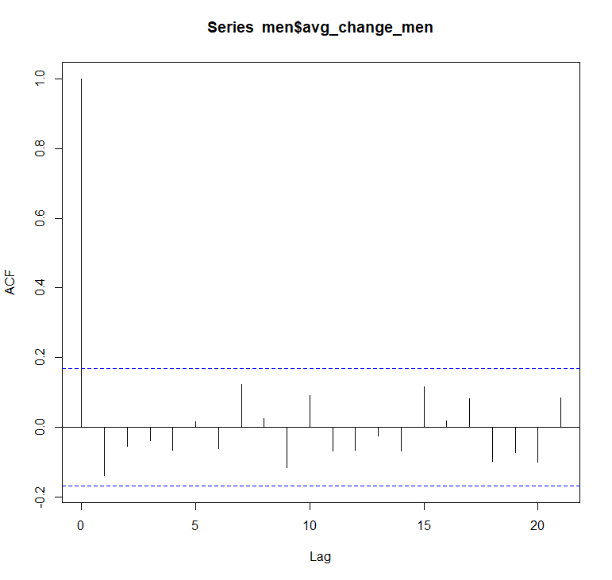

The results of the AR(1) models are below (full results in the Appendix). The models we ran were the following:

*(Avg. % Change for Female Led Companies)t = β0 + β1× (Avg. % Change for Female Led Companies)t-1*

*(Avg. % Change for Male Led Companies)t = β0 + β1× (Avg. % Change for Male Led Companies)t-1*

### Exhibit 13: Regression Results of the AR(1) Model

|  | (F) | (M) |
| --- | --- | --- |
|  | Avg. % Change in Stock  (Month-to-Month) | Avg. % Change in Stock  (Month-to-Month) |
| Intercept | 0.0176** | 0.0171*** |
|  | (0.0058) | (0.0041) |
| Avg. % Change in Stock  (Month-to-Month)t-1 | -0.0686 | -0.139 |
| (0.0864) | (0.08512) |

Based on the results, we can see that both autoregressive terms are not significant at an alpha level of 0.05.

## Interpretation

Since our results were not statistically significant, we cannot conclude any difference between men and women in terms of price increase percentage over time.

# Conclusion

This paper explored the effect of a female and minority led CEO on financial performance, as measured through the stock price over time. We built two different models, a multiple linear regression, and an auto-regressive model, in order to best infer whether there was an effect.

We hypothesized that both female and minority CEOs would have a positive effect on financial performance, and theorized that because there are few women and minorities that reach the top of these organizations, that those who do are more likely to be the most hard-working and motivating individuals in their company. Hence, we expected these individuals to drive their companies to success, and thus have better financial performance. Based on the results of our models, we found no evidence to support this claim, and therefore conclude that there is no statistically significant difference in financial performance of female or minority CEOs of major corporations in comparison to those that are not minority led.

Although we did not find empirical evidence to support that diversity at the highest position of companies improves financial performance there is still much more to explore on this topic. In the future, we hope to look at comparing other measures of success for a company including employee satisfaction, and average customer satisfaction.

# 

# 

# 

# 

# 

# Appendix

### Exhibit 14. Distribution of Stock Price (Female CEOs)

### Exhibit 15. Distribution of Stock Price (Minority CEOs)

### Exhibit 16. Distribution of Stock Price (Other Companies)

*Exhibit 17. Complete Results of Simple Linear Regression*

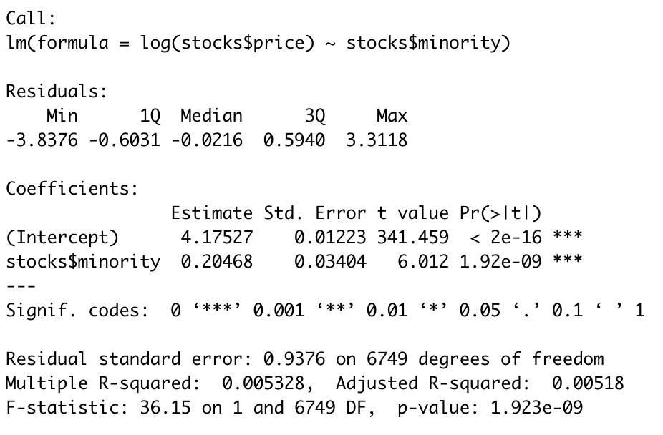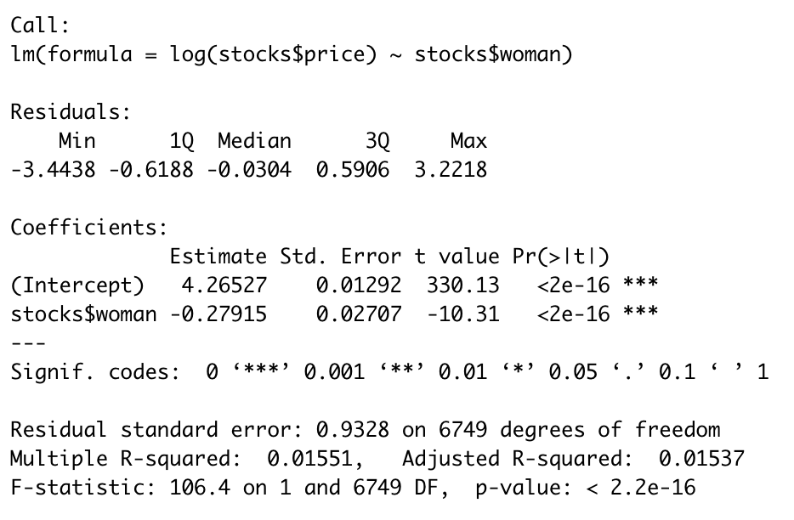

### 

### 

### 

### 

### Exhibit 18. Complete Results of the Multiple Linear Regression

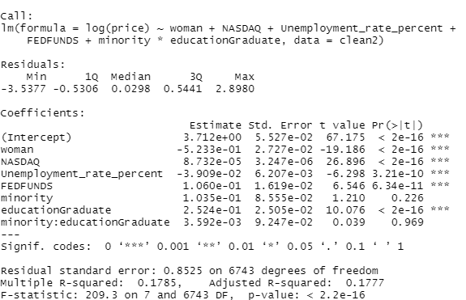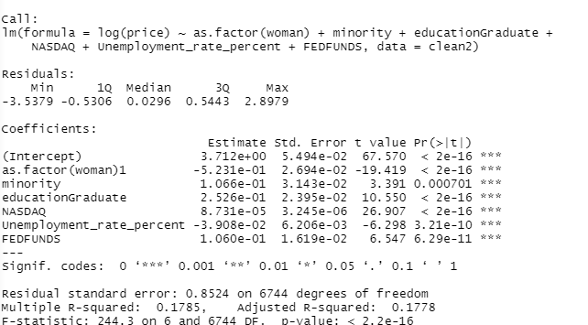

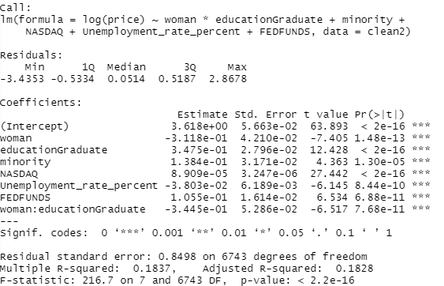

### Exhibit 19. Complete Results of the Multiple Linear Regression with Random Effects

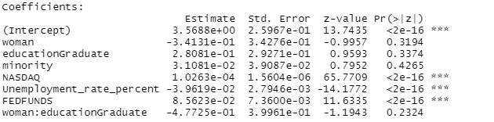

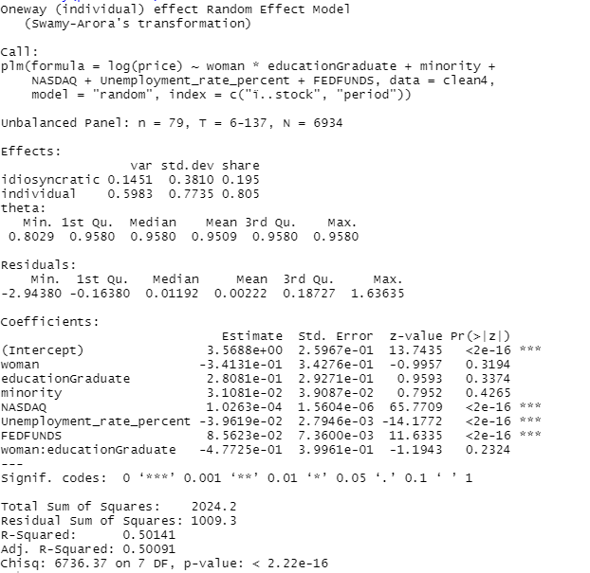

### Exhibit 20. Complete Results of the Multiple Linear Regression with Fixed Effects

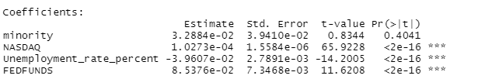

### Exhibit 21. Complete Results *of the AR(1) Model - Dataset F*

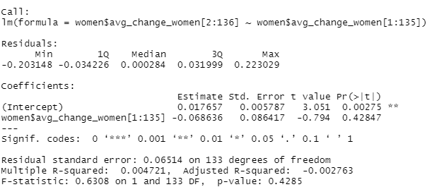

### Exhibit 22. Complete Results of the AR(1) Model - Dataset M

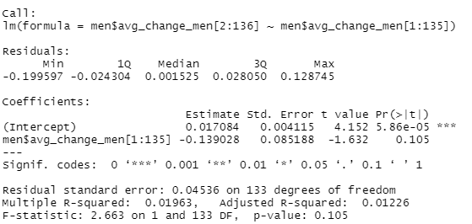

1. Hunt, Vivian, et al. “Delivering through Diversity.” *McKinsey & Company*, McKinsey & Company, 1 Mar. 2021, https://www.mckinsey.com/business-functions/people-and-organizational-performance/our-insights/delivering-through-diversity.
2. Lorenzo, Rocio, et al. “How Diverse Leadership Teams Boost Innovation.” *BCG,* BCG, 23 Jan. 2021, https://www.bcg.com/publications/2018/how-diverse-leadership-teams-boost-innovation.
3. “NASDAQ Composite (^IXIC).” *Yahoo Finance,* https://finance.yahoo.com/quote/%5EIXIC?p=%5EIXIC
4. “S&P 500 (^GSPC) Historical Data.” *Yahoo Finance,* https://finance.yahoo.com/quote/%5EGSPC/history?p=%5EGSPC
5. “Dow Jones Industrial Average (^DJI).” *Yahoo Finance,* https://finance.yahoo.com/quote/%5EDJI/history?p=%5EDJI
6. “ Consumer Price Index for All Urban Consumers: All Items in U.S. City Average.” *FRED*, 1 Dec. 2021, https://fred.stlouisfed.org/series/CPIAUCSL.
7. “Charts Related to the Latest ‘The Employment Situation’ News Release | More Chart Packages.” *U.S. Bureau of Labor Statistics*, U.S. Bureau of Labor Statistics, https://www.bls.gov/charts/employment-situation/civilian-unemployment-rate.htm.
8. “Federal Funds Effective Rate.” *FRED*, 1 Dec. 2021, https://fred.stlouisfed.org/series/FEDFUNDS#0.